CSA1402-COMPLIER DESIGN
PROGRAMS: 18 TO 27
NAME: yogamadha a
Register no: 192425058.
18) Program to Count the Number of Macros and Header Files in a C Program
#include <stdio.h>
#include <string.h>

int main() {
char code[] =
"#define PI 3.14\n"
"#include<stdio.h>\n"
"#include<conio.h>\n"
"void main() {\n"
"int a,b,c = 30;\n"
"printf(\"hello\");\n"
"}\n";

int macro_count = 0, header_count = 0;
char *line = strtok(code, "\n");

while (line != NULL) {
if (strstr(line, "#define"))
macro_count++;
if (strstr(line, "#include"))
header_count++;
line = strtok(NULL, "\n");
}

printf("Number of Macros defined: %d\n", macro_count);
printf("Number of Header files included: %d\n", header_count);
return 0;
}
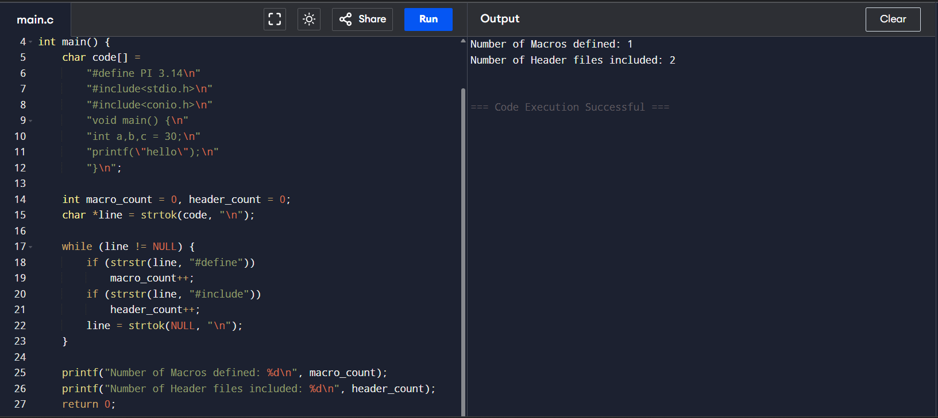

CSA1402-COMPLIER DESIGN
PROGRAMS: 18 TO 27
19)Program to Print All HTML Tags in the Input File
#include <stdio.h>

int main() {
char html[] =
"<html>\n"
"<body>\n"
"<h1>My First Heading</h1>\n"
"<p>My first paragraph.</p>\n"
"</body>\n"
"</html>\n";

int i = 0, inside_tag = 0;

printf("HTML Tags Found:\n");
while (html[i] != '\0') {
if (html[i] == '<') {
inside_tag = 1;
printf("<");
} else if (html[i] == '>') {
printf(">\n");
inside_tag = 0;
} else if (inside_tag) {
printf("%c", html[i]);
}
i++;
}

return 0;
}
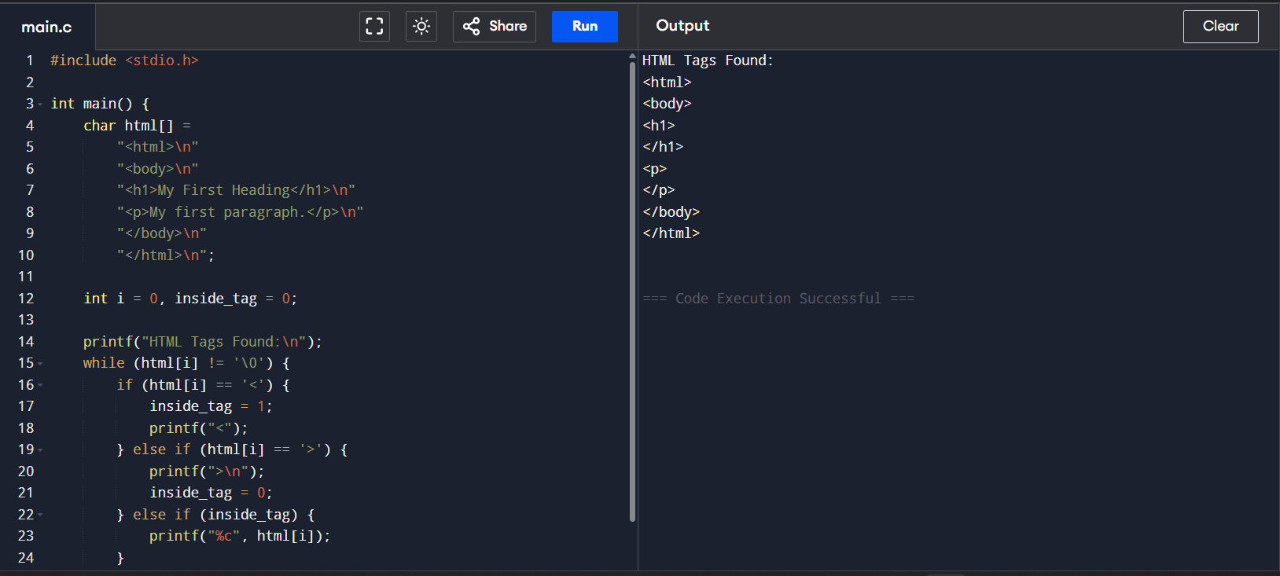

CSA1402-COMPLIER DESIGN
PROGRAMS: 18 TO 27
20) Program to Add Line Numbers to a Given C Program
#include <stdio.h>
#include <string.h>

int main() {
char code[] =
"#define PI 3.14\n"
"#include<stdio.h>\n"
"#include<conio.h>\n"
"\n"
"void main()\n"
"{\n"
"int a,b,c = 30;\n"
"printf(\"hello\");\n"
"}\n";

int line_no = 1;
char *line = strtok(code, "\n");

while (line != NULL) {
printf("%d: %s\n", line_no++, line);
line = strtok(NULL, "\n");
}

return 0;
}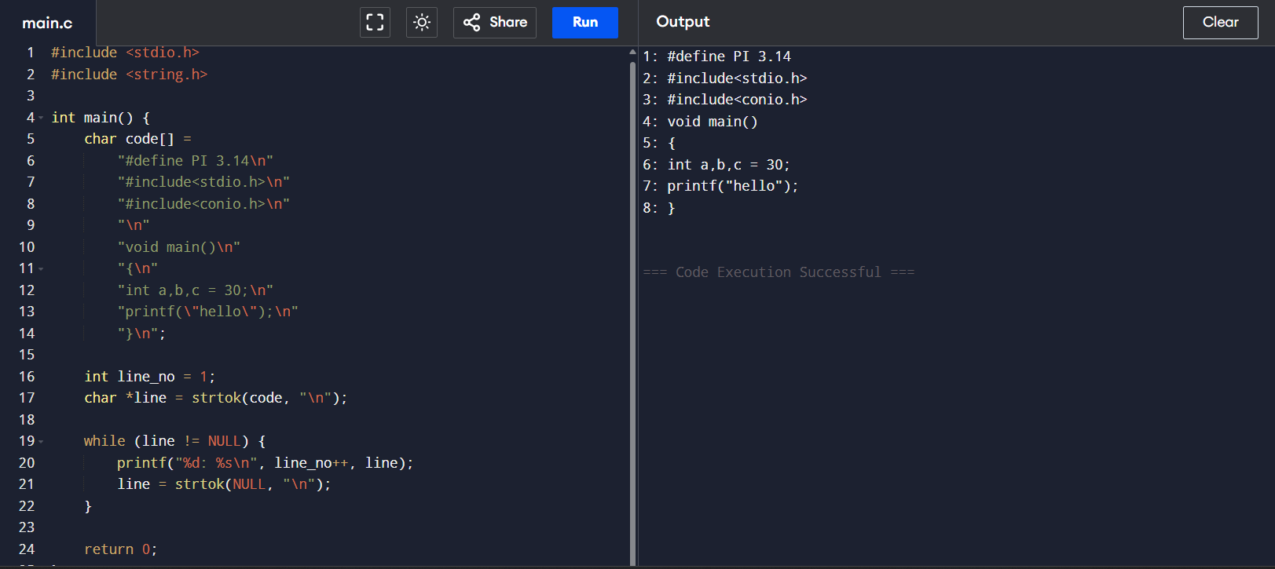

CSA1402-COMPLIER DESIGN
PROGRAMS: 18 TO 27
21) Program to Count the Number of Characters, Words and Lines
#include <stdio.h>
#include <ctype.h>

int main() {
char text[] =
"Hello world\n"
"This is a sample text file\n"
"With three lines.\n";

int chars = 0, words = 0, lines = 0;
int in_word = 0;
char ch;
int i = 0;

while ((ch = text[i++]) != '\0') {
chars++;
if (ch == '\n')
lines++;
if (isspace(ch))
in_word = 0;
else if (!in_word) {
in_word = 1;
words++;
}
}

printf("Number of Characters: %d\n", chars);
printf("Number of Words: %d\n", words);
printf("Number of Lines: %d\n", lines);

return 0;
} 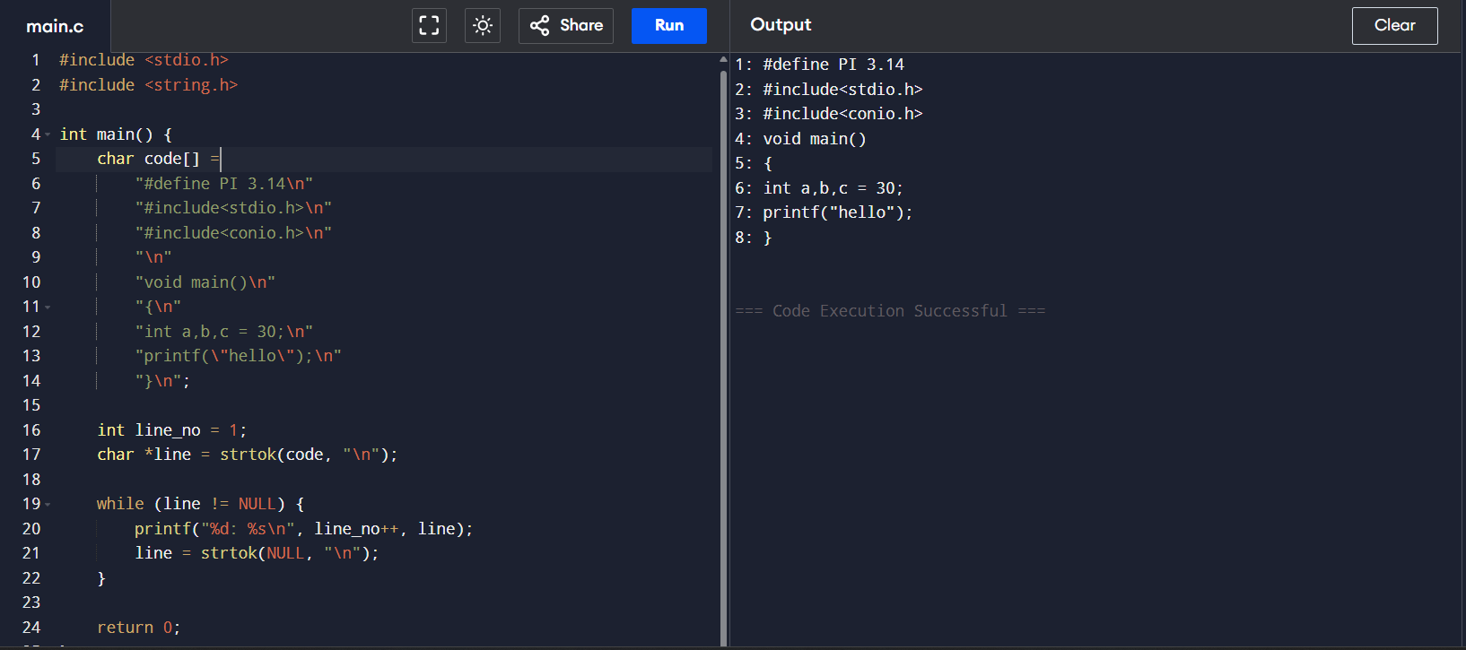

CSA1402-COMPLIER DESIGN
PROGRAMS: 18 TO 27
22) Program to Remove Comment Lines from a C Program
#include <stdio.h>

int main() {
char code[] =
"#include<stdio.h>\n"
"int main() {\n"
"int a,b,c; /* variable declaration */\n"
"printf(\"enter two numbers\");\n"
"scanf(\"%d %d\", &a, &b);\n"
"c = a + b; // adding two numbers\n"
"printf(\"sum is %d\", c);\n"
"return 0;\n"
"}\n";

int i = 0;
int inside_single = 0, inside_multi = 0;

printf("Code after removing comments:\n");

while (code[i] != '\0') {
if (!inside_single && !inside_multi && code[i] == '/' && code[i+1] == '/')
inside_single = 1, i += 2;
else if (!inside_single && !inside_multi && code[i] == '/' && code[i+1] == '*')
inside_multi = 1, i += 2;
else if (inside_single && code[i] == '\n')
inside_single = 0, putchar(code[i++]);
else if (inside_multi && code[i] == '*' && code[i+1] == '/')
inside_multi = 0, i += 2;
else if (!inside_single && !inside_multi)
putchar(code[i++]);
else
i++;
}

return 0;
}
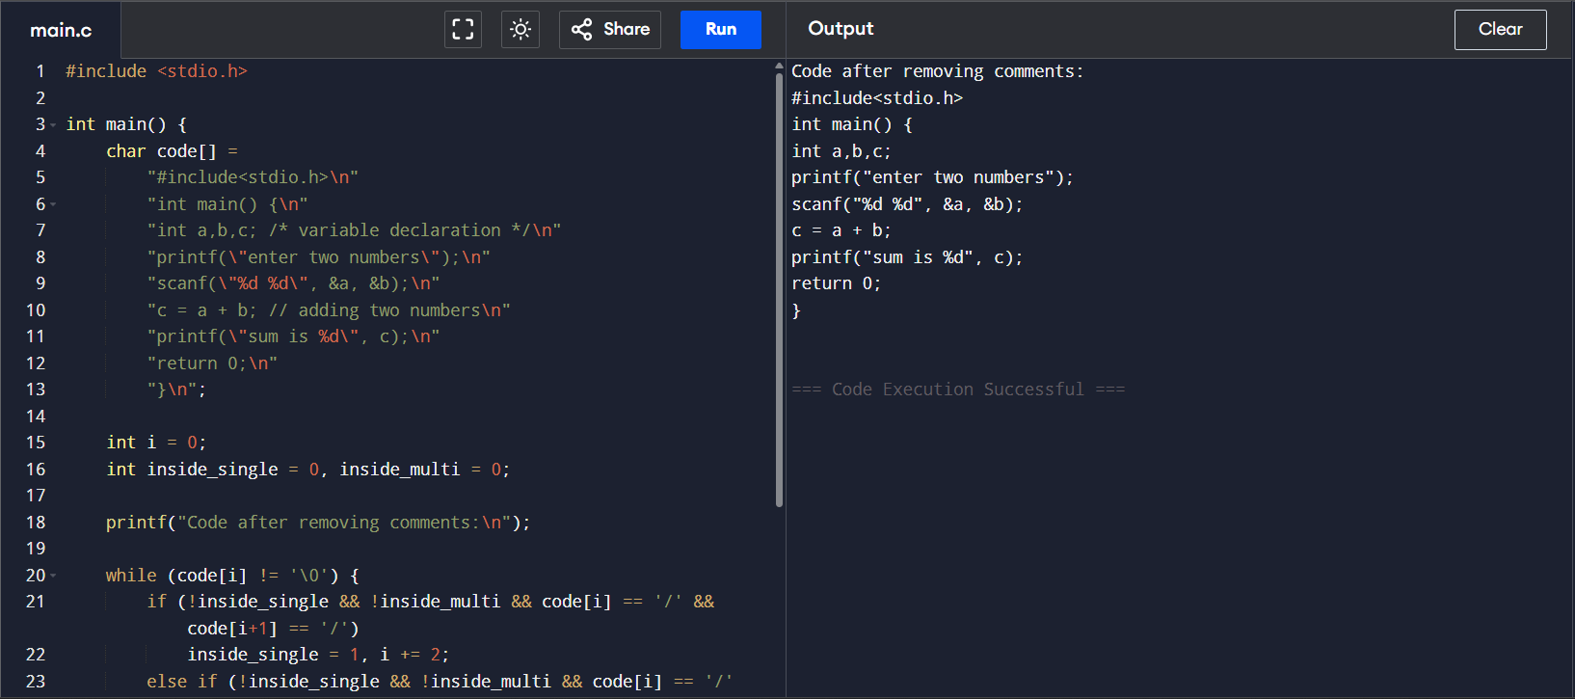

CSA1402-COMPLIER DESIGN
PROGRAMS: 18 TO 27
23) Program to Identify Capital Words from Given Input
#include <stdio.h>
#include <string.h>
#include <ctype.h>

int main() {
char input[200];
printf("Enter a sentence: ");
fgets(input, sizeof(input), stdin); // safe input method

char word[50];
int i = 0, j = 0;

while (1) {
if (input[i] != ' ' && input[i] != '\n' && input[i] != '\0') {
word[j++] = input[i];
} else {
word[j] = '\0';
if (j > 0) {
int isCapital = 1;
for (int k = 0; k < j; k++) {
if (!isupper(word[k])) {
isCapital = 0;
break;
}
}
if (isCapital)
printf("Capital Word: %s\n", word);
j = 0;
}
if (input[i] == '\0')
break;
}
i++;
}
return 0;
}
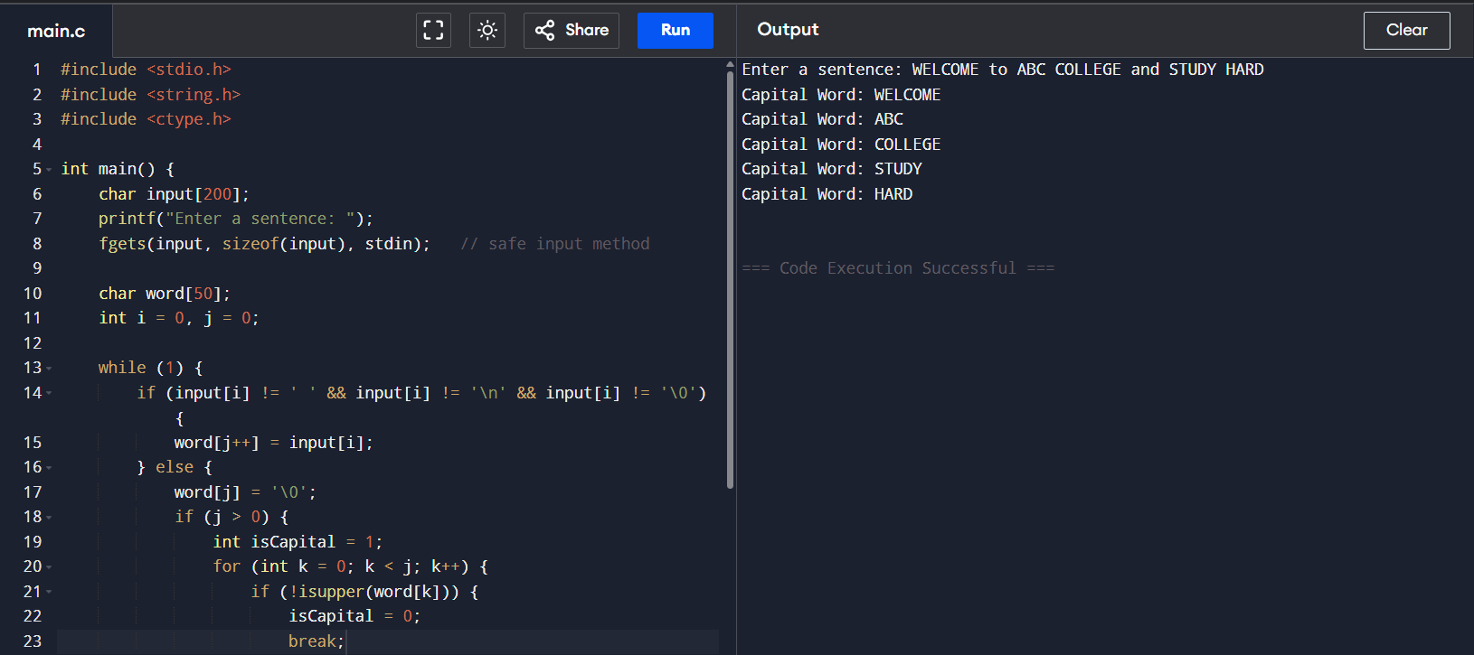

CSA1402-COMPLIER DESIGN
PROGRAMS: 18 TO 27
24) Program to Check Whether an Email Address is Valid or Not
#include <stdio.h>
#include <string.h>

int main() {
char email[100];
int at = 0, dot = 0;

printf("Enter email address: ");
fgets(email, sizeof(email), stdin);

int len = strlen(email);
if (email[len - 1] == '\n') email[len - 1] = '\0';

for (int i = 0; email[i] != '\0'; i++) {
if (email[i] == '@')
at++;
else if (email[i] == '.')
dot++;
}

if (at == 1 && dot >= 1 && strchr(email, '@') < strrchr(email, '.'))
printf("Valid Email Address\n");
else
printf("Invalid Email Address\n");

return 0;
}
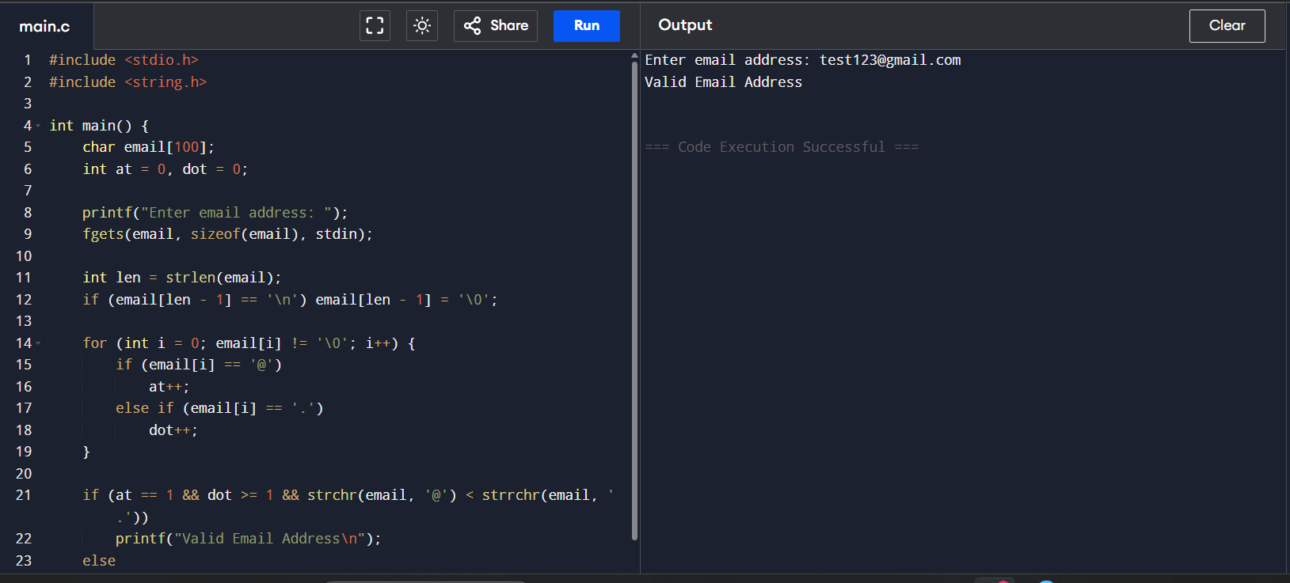

CSA1402-COMPLIER DESIGN
PROGRAMS: 18 TO 27
25) Program to Convert Substring “abc” to “ABC” in the Given String
#include <stdio.h>
#include <string.h>

int main() {
char str[200];
printf("Enter a string: ");
fgets(str, sizeof(str), stdin);

for (int i = 0; str[i] != '\0'; i++) {
if (str[i]=='a' && str[i+1]=='b' && str[i+2]=='c') {
str[i]='A';
str[i+1]='B';
str[i+2]='C';
}
}

printf("Modified String: %s", str);
return 0;
}
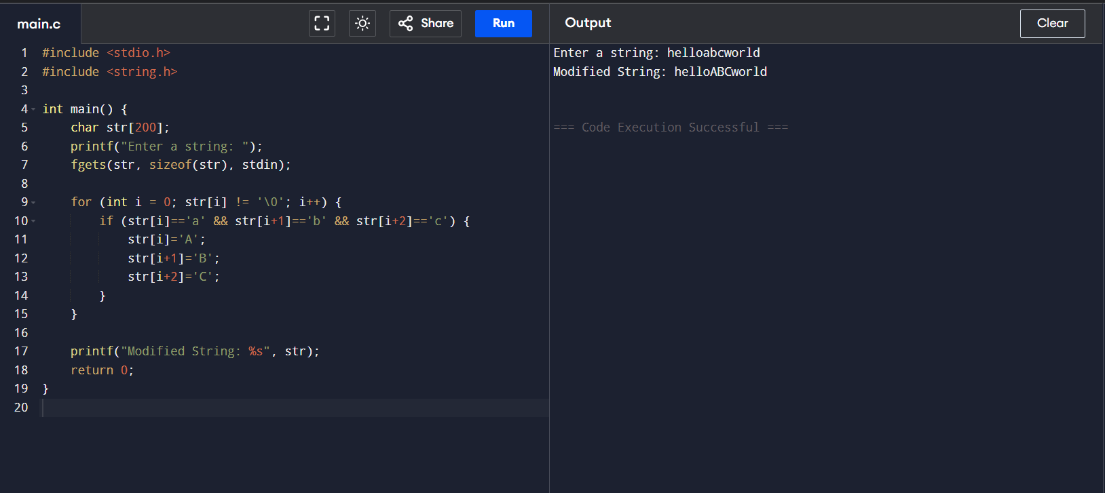

CSA1402-COMPLIER DESIGN
PROGRAMS: 18 TO 27
26) Program to Check Whether a Mobile Number is Valid or Not
#include <stdio.h>
#include <string.h>
#include <ctype.h>

int main() {
char mobile[20];
printf("Enter mobile number: ");
fgets(mobile, sizeof(mobile), stdin);

int len = strlen(mobile);
if (mobile[len - 1] == '\n') {
mobile[len - 1] = '\0';
len--;
}

int valid = 1;

if (len != 10 || mobile[0] < '6' || mobile[0] > '9')
valid = 0;

for (int i = 0; i < len; i++) {
if (!isdigit(mobile[i]))
valid = 0;
}

if (valid)
printf("Valid Mobile Number\n");
else
printf("Invalid Mobile Number\n");

return 0;
}
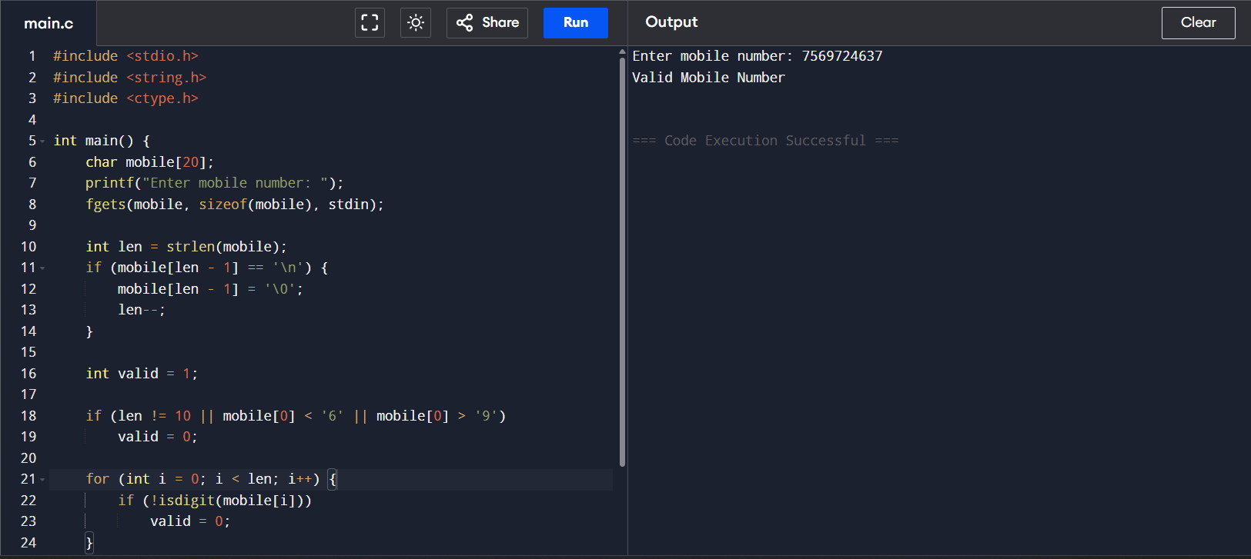

CSA1402-COMPLIER DESIGN
PROGRAMS: 18 TO 27
27) Program to Implement Lexical Analyzer in C
#include <stdio.h>
#include <string.h>
#include <ctype.h>

int main() {
char code[] =
"#include<stdio.h>\n"
"void main() {\n"
"int a,b,c = 30;\n"
"printf(\"hello\");\n"
"}\n";

char *token = strtok(code, " \n\t;(){}=,+-*/");
printf("Tokens in the given C program:\n\n");

while (token != NULL) {
if (strcmp(token, "#include<stdio.h>") == 0)
printf("Header File: %s\n", token);
else if (!strcmp(token, "int") || !strcmp(token, "void"))
printf("Keyword: %s\n", token);
else if (!strcmp(token, "printf"))
printf("Function: %s\n", token);
else if (isdigit(token[0]))
printf("Number: %s\n", token);
else
printf("Identifier: %s\n", token);

token = strtok(NULL, " \n\t;(){}=,+-*/");
}

return 0;
}
